Specification

- Create a data extraction configuration for http://www.aliexpress.com/store/618723 for mydataprovider web scraping service.
- Data extraction scheme is shown on the next image (selected red blocks show which exactly data will be extracted and no one else). Sample for the next page:
http://www.aliexpress.com/store/product/Megir-Brand-Black-Silicone-Strap-Analog-Display-Date-Chronograph-Sport-Watch-Men-Wristwatch-relogio-masculino/618723_2054324160.html
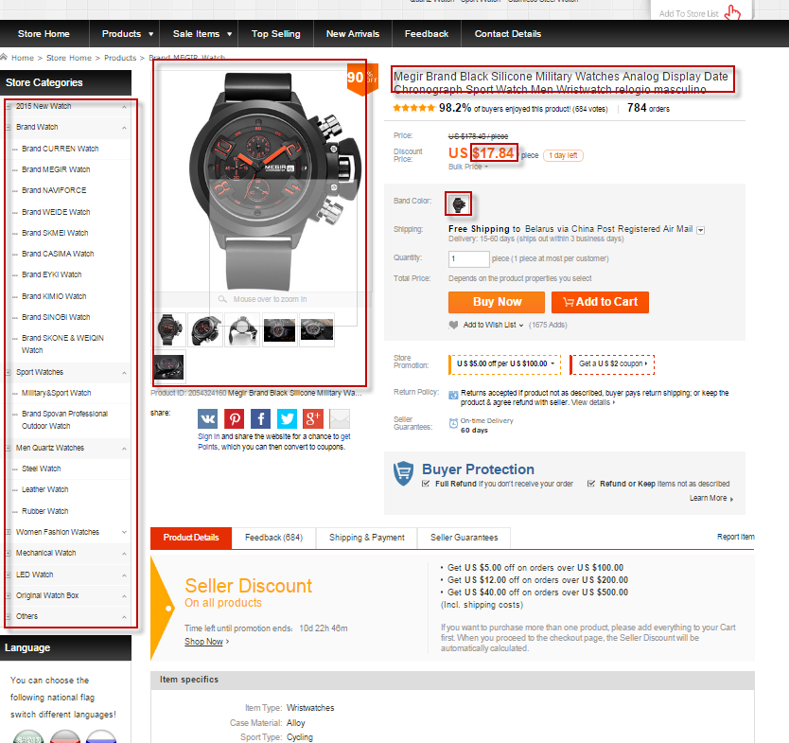
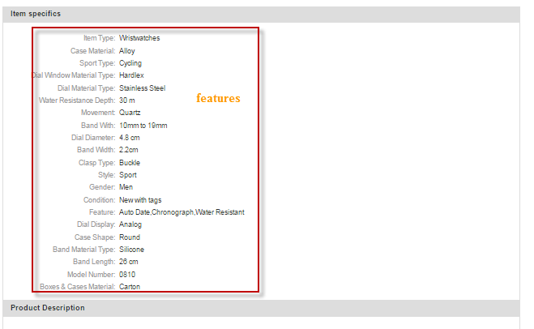
- Source web-site design will not be copied.
- Categories will be copied 1 to 1 exactly. Customer has a possibility to change structure of categories by itself via configuration file if it requires.
- Support period 1 month.

