Specification

- Create a data extraction (web scraper) configuration for amazon.com web site.
- Data extraction scheme is shown on the next image (selected red blocks show which exactly data will be extracted and no one else). Sample for the next page: http://www.amazon.com/s/ref=sr_st_popularity-rank?fst=as%3Aoff&bbn=15743631&qid=1421830136&rh=n%3A7141123011%2Cn%3A7147440011%2Cn%3A15743631%2Cp_85%3A2470955011&sort=popularity-rank

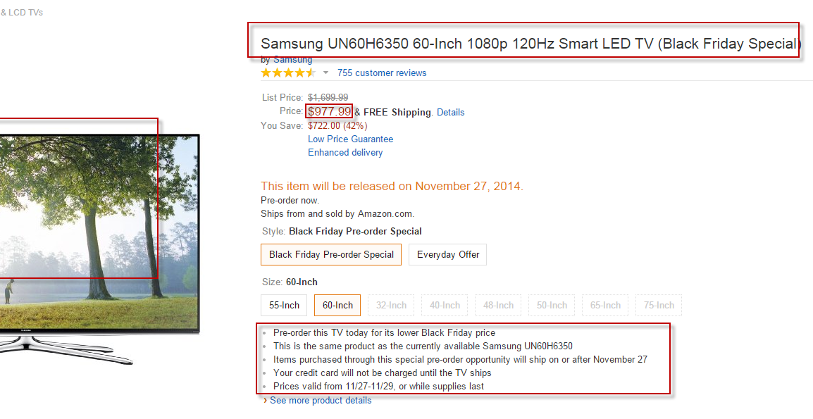

- Source web-site design will not be copied.
- Categories will be copied 1 to 1 exactly. Customer has a possibility to change structure of categories by itself via configuration file if it requires.
- Support period 1 month.

