Specification

- Create a data extraction (web scraper) for amazon.com web site.
- Data extraction scheme is shown on the next image (selected red blocks show which exactly data will be extracted and no one else). Sample for the next page:
http://www.amazon.com/gp/product/B00CBTRY2K/ref=oh_aui_detailpage_o00_s04?ie=UTF8&psc=1
- 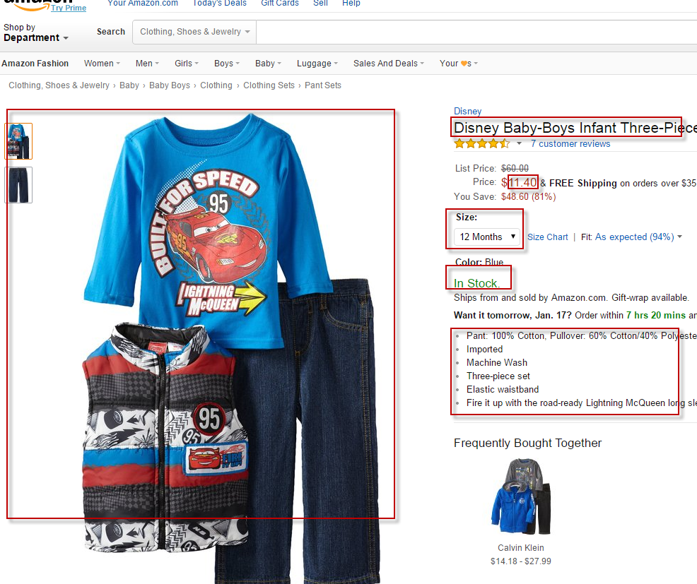

- Source web-site design will not be copied.
- Categories will be copied 1 to 1 exactly. Customer has a possibility to change structure of categories by itself via configuration file if it requires.
- Support period 1 month.

