Specification

- Create a data extraction configuration for sportsdirect.com for mydataprovider.com web scraping service.
User settings:
- Country: France,
- price: Euro

- Export format: XML
- Data extraction scheme is shown on the next image (selected red blocks show which exactly data will be extracted and no one else). Sample for the next page:
http://www.sportsdirect.com/nike-flex-experience-5-running-shoes-ladies-271038?colcode=27103840
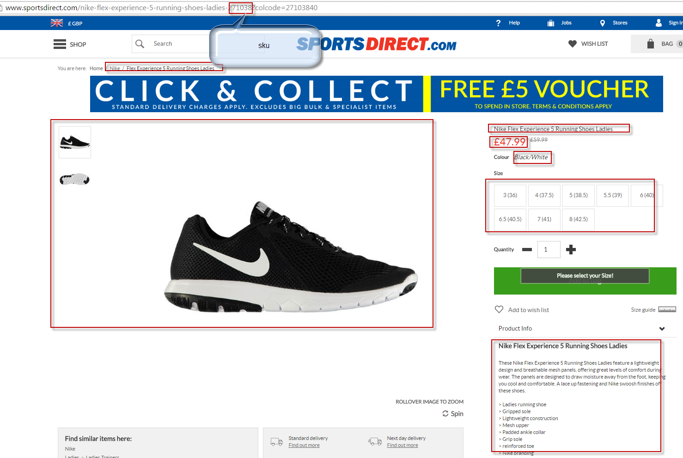

- Source web-site design will not be copied.
- Categories will be copied 1 to 1 exactly. Customer has a possibility to change structure of categories by itself via configuration file if it requires.
- Support period 1 month.

